Create ci pipeline that will deploy and configure these VMs using terraform and ansible according following requirements
- Deploy 2 virtual machines using terraform.
  - first vm on Amazon linux, hostname: c8.local
  - second vm on ubuntu 21.04, hostname: u21.local
Create Ec2 instance with t2 large with 20gb volume
Install Git, Terraform, Ansible
To install Terraform on Amazon linux, you can follow these steps:
1. Update and install prerequisites
sudo dnf-get update && sudo dnf-get install -y gnupg software-properties-
common curl
2. Add the HashiCorp GPG key
curl -fsSL https://apt.releases.hashicorp.com/gpg | sudo apt-key add –
- Add the official HashiCorp Linux repository
- sudo dnf-add-repository "deb [arch=amd64] https://apt.releases.hashicorp.com $
(lsb_release -cs) main"
4. Install Terraform
sudo apt-get update && sudo apt-get install -y terraform
5. Verify installation
terraform -version
https://github.com/ALEEMUDDIN138/ci-terraform-ansible.git
clone this url
Cd ci-terraform-ansible
Cd terraform
Create three files: variable.tf, main.tf & output.tf
Vi variables.tf
In this file edit the region, pemkey, and ami ids
variable.tf:
variable "aws_region" {
type = string
default = "us-east-1"
}
variable "key_name" {
type = string
description = "Name of EC2 keypair (must already exist in the region)"
default = "Virginia"
}

variable "ami_amazon_linux" {
type = string
description = "AMI ID for Amazon Linux"
default = "ami-08982f1c5bf93d976"
}
variable "ami_ubuntu" {
type = string
description = "AMI ID for Ubuntu 21.04"
default = "ami-0360c520857e3138f"
}
variable "instance_type" {
type = string
default = "t3.micro"
}
# ✅ New variable for public IP
variable "associate_public_ip" {
type = bool
description = "Whether to associate a public IP with the instance"
default = true
}

main.tf:
provider "aws" {
region = var.aws_region
}

# Security Group allowing SSH and HTTP
resource "aws_security_group" "ec2_sg" {
name = "Virginia"
description = "Allow SSH and HTTP inbound traffic"
ingress {
from_port = 22
to_port = 22
protocol = "tcp"
cidr_blocks = ["0.0.0.0/0"] # allow SSH from anywhere (restrict in production)
}
ingress {
from_port = 80
to_port = 80
protocol = "tcp"
cidr_blocks = ["0.0.0.0/0"] # allow HTTP
}
egress {
from_port = 0
to_port = 0
protocol = "-1"
cidr_blocks = ["0.0.0.0/0"]
}
}
# EC2 instance with public IP
resource "aws_instance" "amazon_linux" {
ami = var.ami_amazon_linux
instance_type = var.instance_type
key_name = var.key_name
vpc_security_group_ids = [aws_security_group.ec2_sg.id]
associate_public_ip_address = true # ✅ ensures public IP
tags = {
Name = "AmazonLinux-Instance"
}
}
resource "aws_instance" "ubuntu" {
ami = var.ami_ubuntu
instance_type = var.instance_type
key_name = var.key_name
vpc_security_group_ids = [aws_security_group.ec2_sg.id]
associate_public_ip_address = true # ✅ ensures public IP
tags = {
Name = "Ubuntu-Instance"
}
}
# Output public IPs
output "amazon_linux_public_ip" {
value = aws_instance.amazon_linux.public_ip
}
output "ubuntu_public_ip" {
value = aws_instance.ubuntu.public_ip
}

output.tf:
output "frontend" {
value = {
hostname = "c8.local"
public_ip = aws_instance.amazon_linux.public_ip
private_ip = aws_instance.amazon_linux.private_ip
}
}
output "backend" {
value = {
hostname = "u21.local"
public_ip = aws_instance.ubuntu.public_ip
private_ip = aws_instance.ubuntu.private_ip
}
}

- You can install the AWS CLI v2 on Ubuntu with these steps:
1. Update system
sudo dnf-get update -y
2. Install unzip (needed to extract AWS CLI package)
sudo apt-get install -y unzip curl
3. Download AWS CLI v2 package
curl "https://awscli.amazonaws.com/awscli-exe-linux-x86_64.zip" -o
"awscliv2.zip"
4. Unzip the installer
unzip awscliv2.zip
5. Run the installer
sudo ./aws/install
6. Verify installation
aws --version
Terraform init
Terraform apply
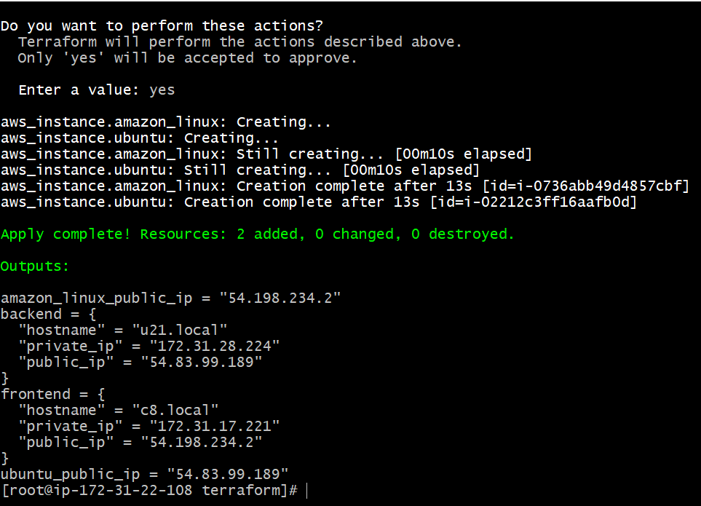
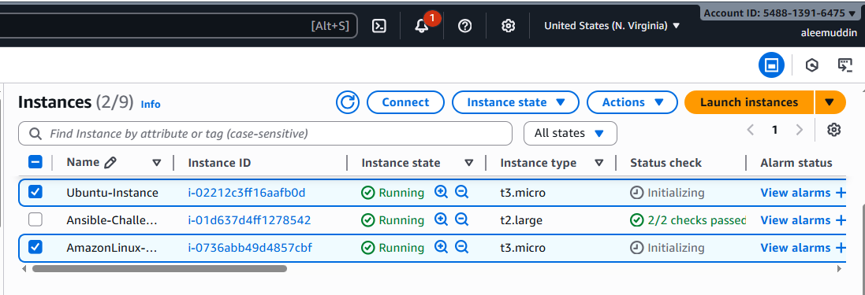
- As a result of terraform execution, dynamically create inventory for ansible
  - c8.local should be in the frontend group
  - u21.local should be in the backend group
configure the inventory:
vi ansible.cfg
[defaults]
inventory = ./inventory.ini
host_key_checking = False
deprecation_warnings = False
retry_files_enabled = False

Configure the hosts
[frontend]
c8.local ansible_host=<frontend-server-ip> ansible_user=ec2-user ansible_ssh_private_key_file=keys/ansible.pem

[backend]
u21.local ansible_host=<backend-server-ip> ansible_user=ubuntu ansible_ssh_private_key_file=keys/ansible.pem ansible_port=22

Configure generate_inventory.py file:
#!/usr/bin/env python3
import json
import subprocess
import os
import sys

# Path to your Terraform root folder (adjust if needed)
terraform_dir = "../terraform"

# Run Terraform output in the correct folder
try:
result = subprocess.run(
["terraform", "output", "-json"],
cwd=terraform_dir,
check=True,
capture_output=True,
text=True
)
data = json.loads(result.stdout)
except subprocess.CalledProcessError as e:
print("Error running terraform output:", e)
sys.exit(1)
except json.JSONDecodeError as e:
print("Error parsing JSON from terraform output:", e)
sys.exit(1)

# Extract frontend and backend outputs
frontend = data.get("frontend", {}).get("value")
backend = data.get("backend", {}).get("value")

if not frontend or not backend:
print("Terraform output is missing 'frontend' or 'backend' values")
sys.exit(1)

# Write inventory file
inventory_file = "inventory.ini"
with open(inventory_file, "w") as f:
f.write("[frontend]\n")
f.write(
f"{frontend['hostname']} "
f"ansible_host={frontend['public_ip']} "
f"ansible_user=ec2-user "
f"ansible_ssh_private_key_file=keys/Virginia.pem\n\n"
)

f.write("[backend]\n")
f.write(
f"{backend['hostname']} "
f"ansible_host={backend['public_ip']} "
f"ansible_user=ubuntu "
f"ansible_ssh_private_key_file=keys/Virginia.pem "
f"ansible_port=22\n"
)

print(f"{inventory_file} generated successfully!")

Configure inventory.json file:
{}

Configure site.yml:
---
- hosts: frontend
become: yes
roles:
- frontend

- hosts: backend
become: yes
roles:
- backend

Important notes:
“In this challenge, the frontend node (c8.local) is accessible via its public IP, allowing it to act as a reverse proxy. It fetches and displays metrics from the backend node (u21.local) running Netdata on port 19999. This setup demonstrates how a publicly reachable frontend can securely visualize internal backend monitoring data.”
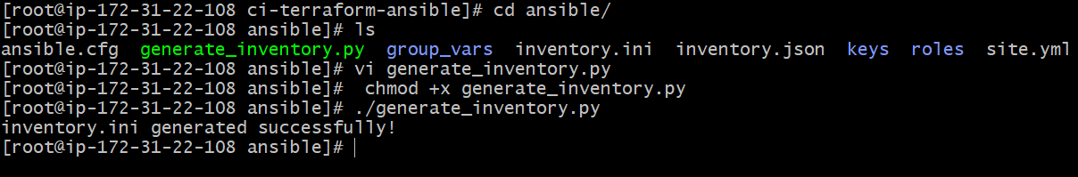
- Create ansible playbook for c8.local and u21.local
Here we have created the playbook for frontend c8.local --> cd ansible --> ls --> cd role --> ll --> cd frontend --> ls --> cd tasks --> ls --> main.yml
---
- name: Disable SELinux (Amazon Linux)
command: setenforce 0
ignore_errors: yes
when: ansible_os_family == "RedHat"
- name: Permanently disable SELinux
replace:
path: /etc/selinux/config
regexp: '^SELINUX=.*'
replace: 'SELINUX=disabled'
when: ansible_os_family == "RedHat"
- name: Disable and stop firewalld (Amazon Linux)
service:
name: firewalld
state: stopped
enabled: no
become: yes
ignore_errors: yes
when: ansible_os_family == "RedHat"
- name: Install Nginx on Debian/Ubuntu
apt:
name: nginx
state: present
update_cache: yes
become: yes
when: ansible_os_family == "Debian"
- name: Install Nginx on Amazon Linux
yum:
name: nginx
state: present
become: yes
when: ansible_os_family == "RedHat"
- name: Ensure Nginx is started and enabled (Amazon Linux)
service:
name: nginx
state: started
enabled: yes
become: yes
when: ansible_os_family == "RedHat"
- name: Configure Nginx proxy to backend
copy:
dest: /etc/nginx/conf.d/backend_proxy.conf
content: |
server {
listen 80;
location / {
proxy_pass http://{{ hostvars['u21.local'].ansible_host }}:19999/;
proxy_set_header Host $host;
proxy_set_header X-Real-IP $remote_addr;
}
}
become: yes
notify:
- Restart Nginx
- name: Start and enable Nginx
service:
name: nginx
state: started
enabled: yes
# Handlers
- name: Reload Nginx
service:
name: nginx
state: reloaded
Here we have created the playbook for backend u21.local -->cd ansible --> ls --> cd role --> ll --> cd frontend --> ls --> cd tasks --> ls --> main.yml

---
- name: Install prerequisites
become: yes
block:
- name: Install software-properties-common on Ubuntu
apt:
name: software-properties-common
state: present
update_cache: yes
when: ansible_os_family == "Debian"
- name: Install prerequisites on Amazon Linux
yum:
name: curl
state: present
when: ansible_os_family == "RedHat"
- name: Install Netdata
become: yes
block:
- name: Install Netdata on Ubuntu
shell: curl -SsL https://my-netdata.io/kickstart.sh | bash
args:
executable: /bin/bash
when: ansible_os_family == "Debian"
- name: Install Netdata on Amazon Linux
shell: curl -SsL https://my-netdata.io/kickstart.sh | bash
args:
executable: /bin/bash
when: ansible_os_family == "RedHat"

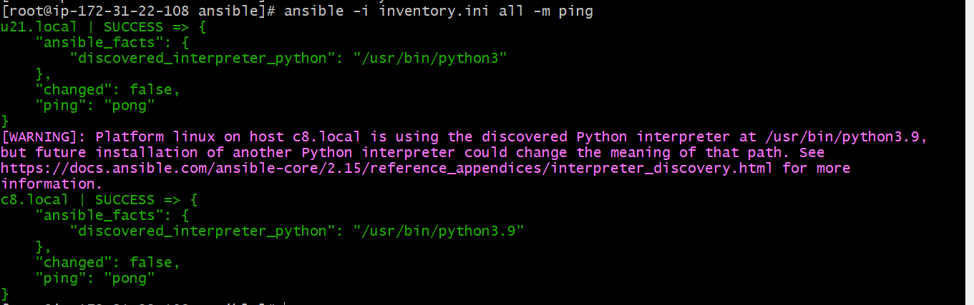
- for linux OS playbook should apply the following changes
  - selinux: disable
  - firewalld: disable
Need to in ansible/roles/frontend/tasks/vi main.yml updated this below playbook in both frontend and backend, then in keys I have updated the public keyand gave permission ---> chmod 600 /root/ci-terraform-ansible/ansible/keys/new.pem
Site.yml file:
---
- hosts: frontend
become: yes
roles:
- frontend
- hosts: backend
become: yes
roles:
- backend
main.yml of frontend and backend:
---
- name: Disable SELinux temporarily
command: setenforce 0
ignore_errors: yes
when: ansible_os_family == "RedHat"
- name: Disable SELinux permanently
replace:
path: /etc/selinux/config
regexp: '^SELINUX=.*'
replace: 'SELINUX=disabled'
when: ansible_os_family == "RedHat"
- name: Stop and disable firewalld
service:
name: firewalld
state: stopped
enabled: no
become: yes
ignore_errors: yes
when: ansible_os_family == "RedHat"

ansible-playbook -i inventory.ini site.yml
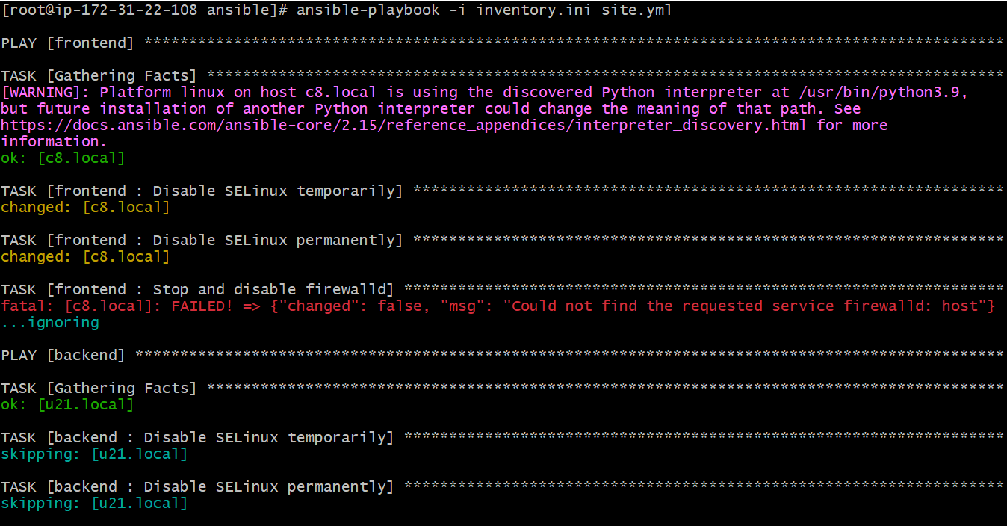
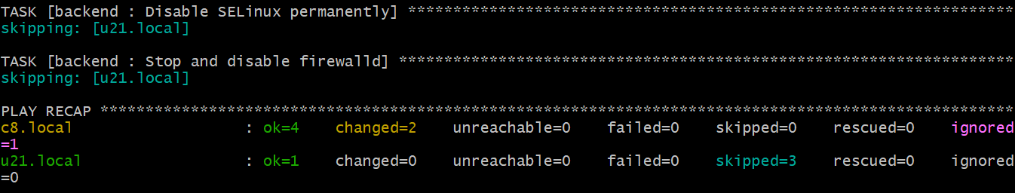

- for frontend playbook group should install and configure nginx
  - nginx configuration should do proxying from port 80 on port 19999 to the
  - backend group
Need to go in ansible/roles/frontend/tasks/main.yml and update this playbook in that file for install and for same need to update theplaybook script in backend as well
# Install Nginx on Debian/Ubuntu
- name: Install Nginx on Debian/Ubuntu
apt:
name: nginx
state: present
update_cache: yes
become: yes
when: ansible_os_family == "Debian"

# Install Nginx on Amazon Linux / RedHat
- name: Install Nginx on Amazon Linux / RedHat
yum:
name: nginx
state: present
become: yes
when: ansible_os_family == "RedHat"

# Ensure Nginx is started and enabled
- name: Start and enable Nginx
service:
name: nginx
state: started
enabled: yes
become: yes
And now go to ansible/roles/frontend/handlers/main.yml
- name: Reload Nginx
service:
name: nginx
state: reloaded
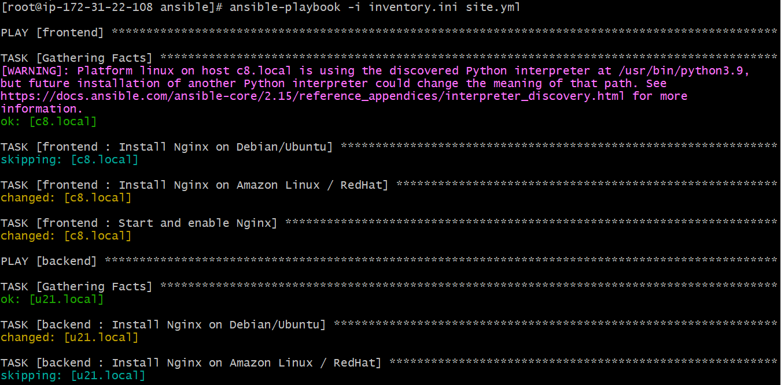
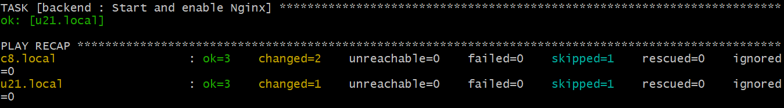
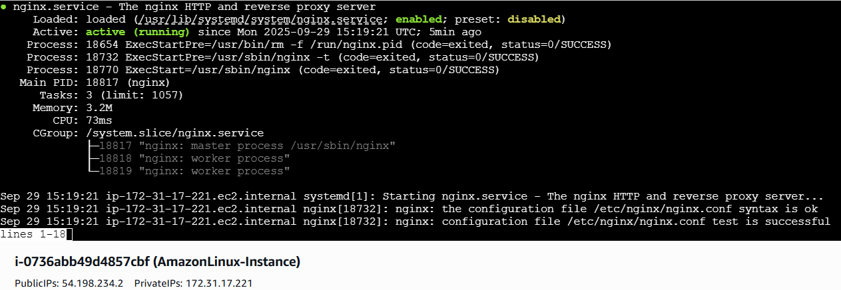
- for the backend group, the playbook must install the Netdata application from the official repositories and run it on port 19999.
Site.yml:
---
- name: Configure backend servers
hosts: backend
become: yes
roles:
- backend

cd ci-terraform-ansible/ansible/roles/backend/tasks/
main.yml:
---
- name: Ensure required dependencies are installed (Debian/Ubuntu)
ansible.builtin.apt:
name:
- curl
- wget
state: present
update_cache: yes
when: ansible_os_family == "Debian"

- name: Ensure required dependencies are installed (Amazon Linux 2023)
ansible.builtin.yum:
name:
- curl-minimal
- wget
state: present
when: ansible_distribution == "Amazon" and ansible_distribution_major_version == "2023"

- name: Ensure required dependencies are installed (Amazon Linux 2 / RHEL / CentOS)
ansible.builtin.yum:
name:
- curl
- wget
state: present
when: ansible_os_family in ["RedHat", "Amazon"] and ansible_distribution_major_version != "2023"

- name: Download Netdata kickstart script
ansible.builtin.get_url:
url: https://my-netdata.io/kickstart.sh
dest: /tmp/kickstart.sh
mode: '0755'

- name: Run Netdata installer
ansible.builtin.command: bash /tmp/kickstart.sh --disable-telemetry
args:
creates: /usr/sbin/netdata

- name: Enable and start Netdata service
ansible.builtin.systemd:
name: netdata
enabled: yes
state: started

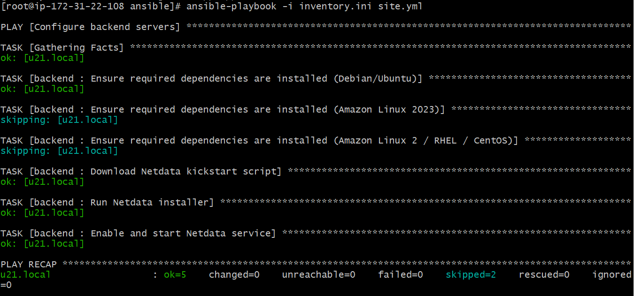
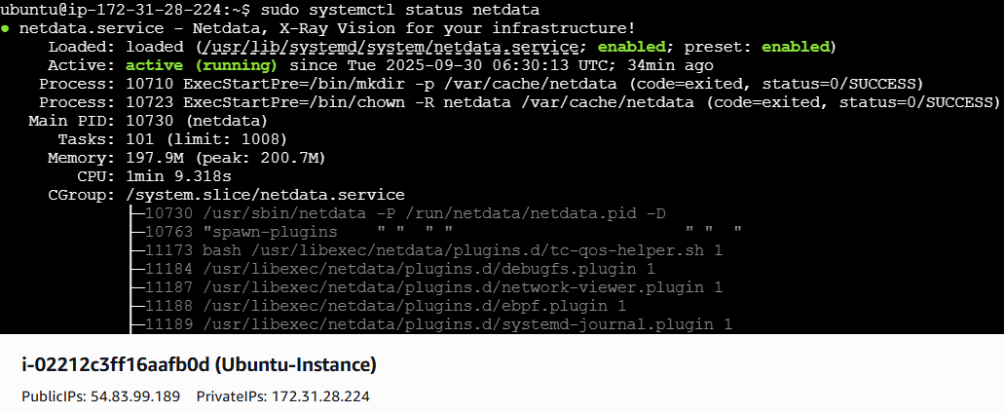
http://<public i.p>:19999
